Workshop III: Friday 25. August 9.00 – 11.15 hrs
Thrown ashore …
In the afternoon we will encounter the visible results of war and evil: thousands of young people who found their lives ended ashore, in foreign territory

- Exploration by reading and bodily work of the text
http://www.biblestudytools.com/niv/
- Read the sentence in different languages
“Toen, op bevel van de HEER, spuwde de vis Jona uit op het land.”
“And the Lord commanded the fish, and it vomited Jonah onto dry land.
"Und der Herr befahl den Fischen, und es erbrach Jona auf trockenes Land”. (Duits)
"Och Herren befallde fisken, och det krävde Jona på torrt land.(Zweeds)
"És az Úr parancsolta a halat, és megfertõzte Jónát szárazföldre.(Hongaars)

- Images of Jonah: spat out on the beach

On the walls of the room there are a lot of pictures of Jonas spat out on the beach. After viewing the Bible text again (in different languages), participants see images of being exclaimed on the country and inspired. What image do you draw, which image repels you, what's up with you ...
See: Images Thrown ashore.
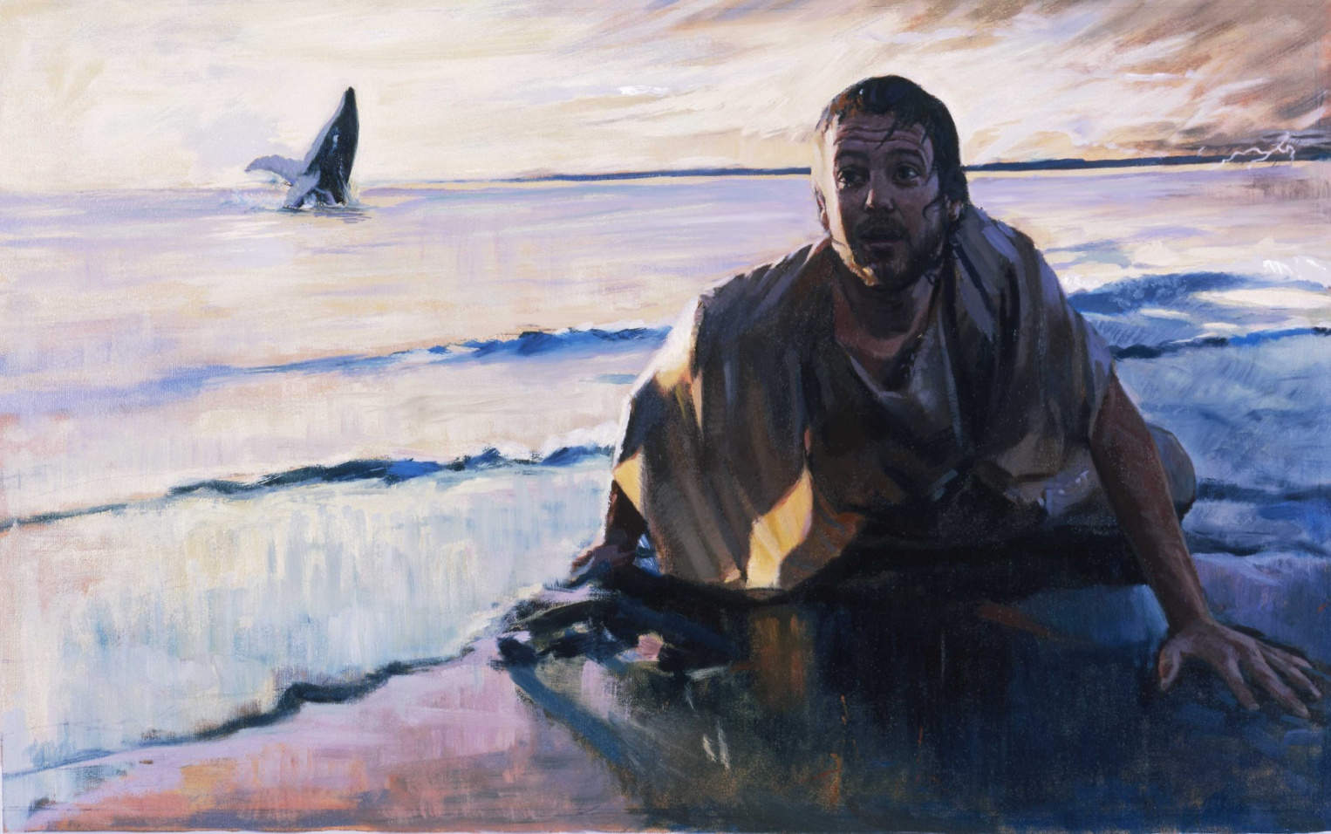
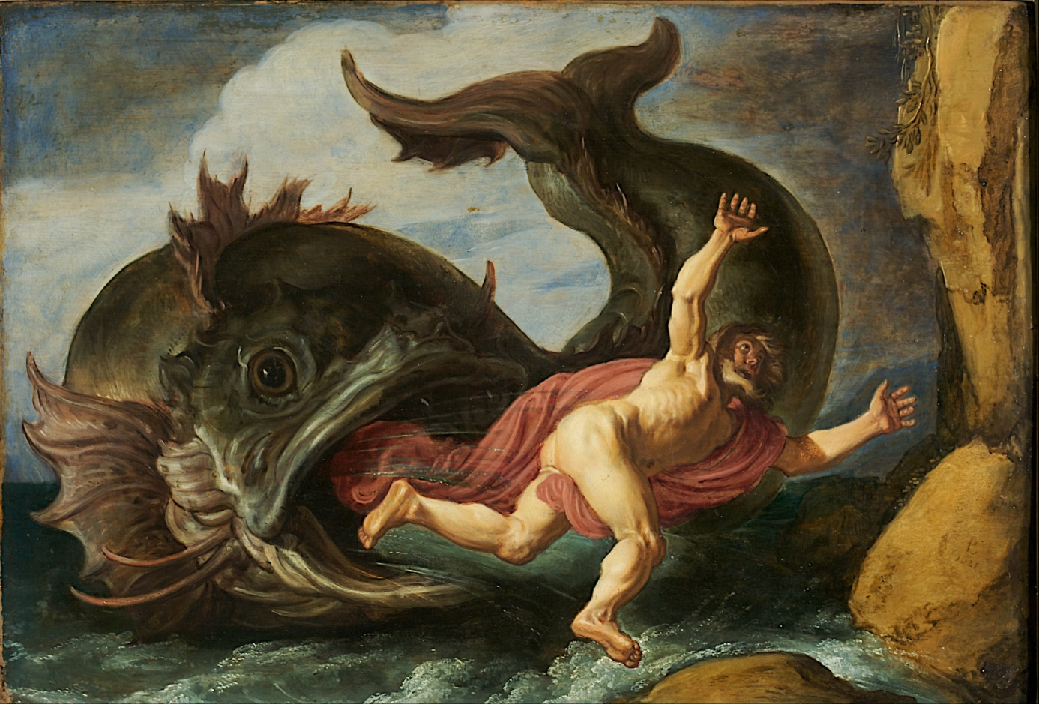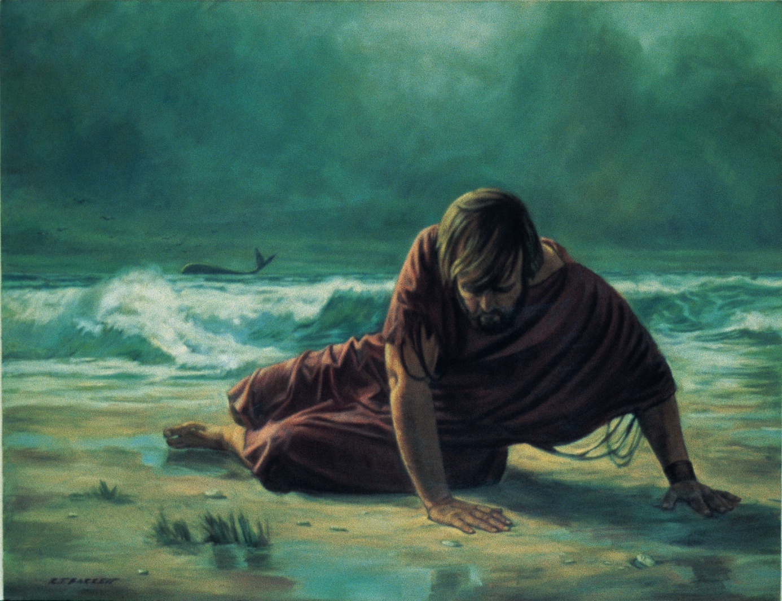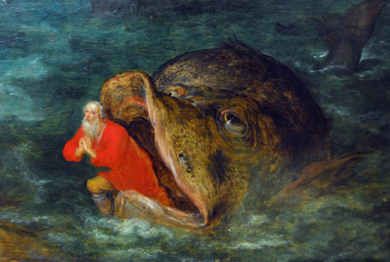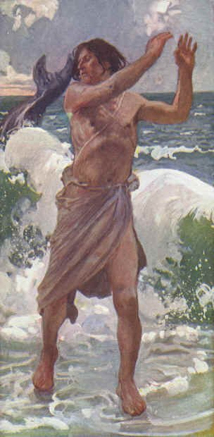
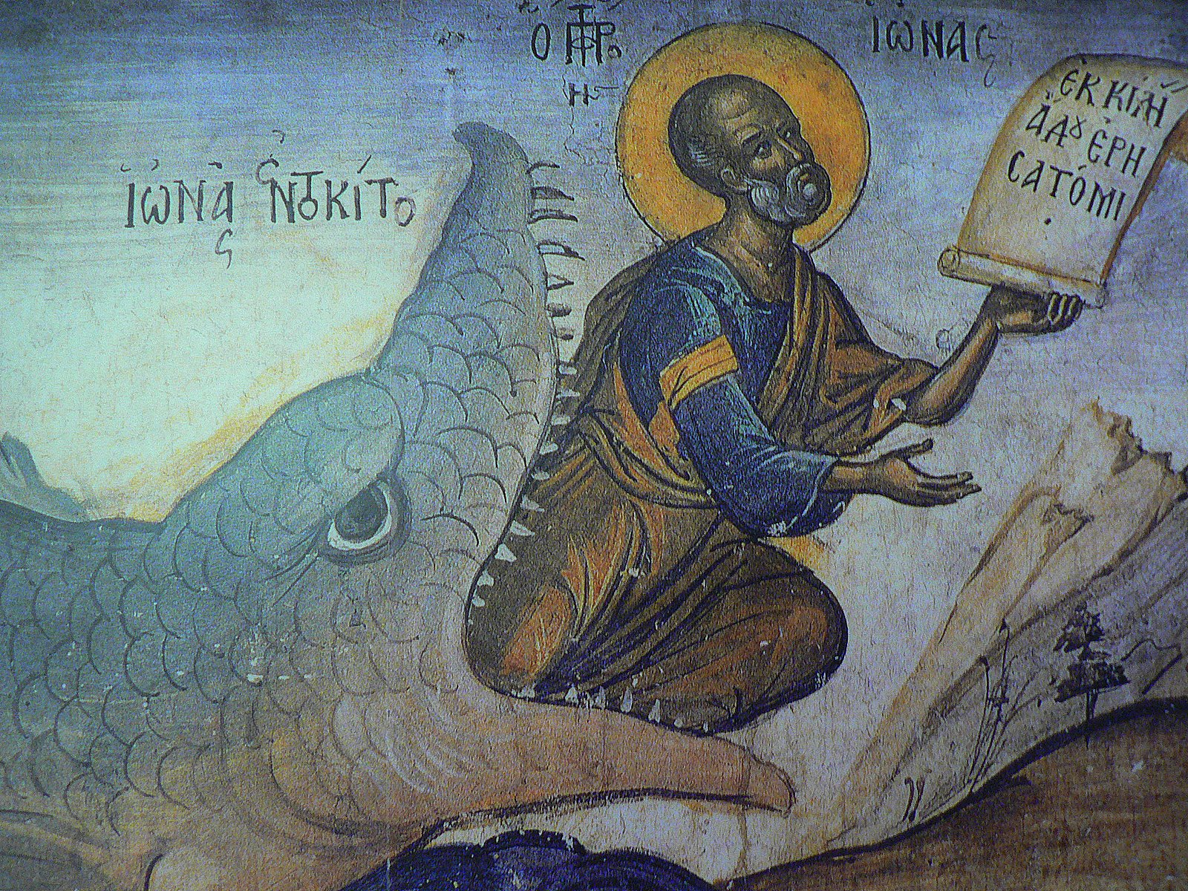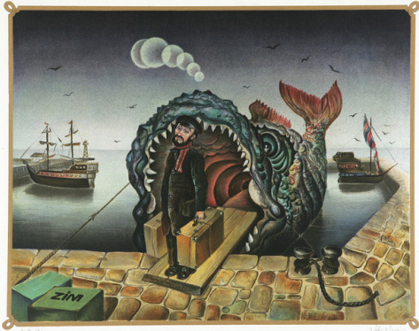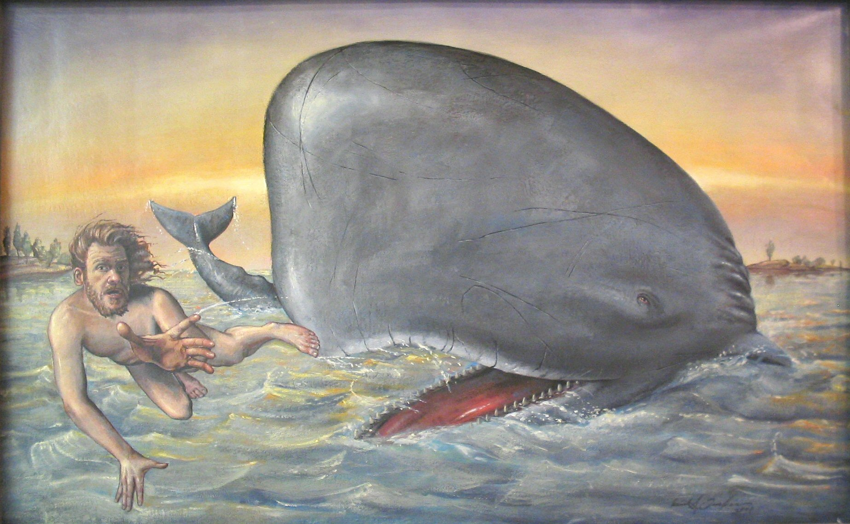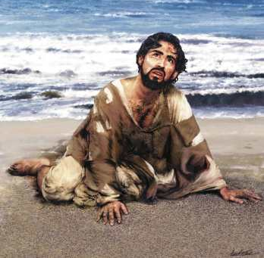
- Sea and land
The participants search for the materials, "clothes", that symbolically illustrate aspects of the transition of sea and land in their perception of the story. These clothes are laid down on the edge of the playing field one by one. The clothes represent the transition sea - beach on which Jonah is spotted.
Each participant speaks as part of an element of the sea and land, something of what this beach calls, where it is part of, an aspect, characteristic ... Which experiences, images, fears, desires and realities are evoked in you (from the depths of the sea, from the locked inner ...) The position of the player in the transition from sea to land is interpreted with the symbolic clothes that form a contiguous large circle within which the following activity will take place later.

- Spiral dance: Spat out
- Goal of the dance in the role of Jonah.

The assignment for this part of the play should be properly explained before the beginning of the dance.
The participants live as Jonas who is in the process of being thrown into the sea, who is swallowed up by the fish, stays in the depths and is excavated on the land.
In a spiral dance, the participants move step by step, slowly moving to the center (symbolized here as a whale)
The dance puts the emphasis on dancing while facing outside, i.e. the second dance part. The participants are called to experience facing outside as the opening from the depths of the whale into the whale, to be spotted on the beach.

How do you experience this transition as a participant, dancer, like Jonah? Pay attention to what happens to you while dancing outside. Stand by your own experiences in your body and mind.
At the end of the dance when the music stops and everybody faces out in a big circle ... everyone immediately takes an bodily position like Jonah who has been exclaimed on the land.

- Dance passes
The dancers stand hand in hand in a semi-open circle.
Part 1 consists of 16 slow steps.
1 hard step on right foot and a soft step left sideways (8 x)
Then part 2 with 4x4 quick little steps forward. The first of the four is hard and the other three are soft.

Norwich Pagan music: 5 min.
https://www.youtube.com/watch?v=3pTUvB9uExI&list=PLsrbgLKTkqvdxkT2a2AidCDuonUtjTMGB&index=3

- Jona was spat on the land

• Role experience
The explanation for this part of the play should be given before the beginning of the dance (13) At the end of the dance when the music stops and everybody faces out in a big circle ... everyone immediately takes an attitude like Jonas who has been spat on the land. Standing, sitting, kneeling, lying, twisted or lingering
How do you sit, lie there like Jonah? What do you feel you are experiencing? On the edge of sea and land. What is the first feeling, experience? Are you exhausted or grieved? Surprised or overcome? What are you aiming for? Where do you want to go?
Take time for the moment of survival. Everyone speaks one sentence like Jonah.

- Exchange
Everyone stays in the role of Jonah in the exchange and also encloses oneself with the materials that represents the country as a beach. Tell your own experiences as Jonah and explain the possible meanings of the beach. The unrolling takes place after each individual exchange. Step-by-step one can make room for the current experience and associations at the game.
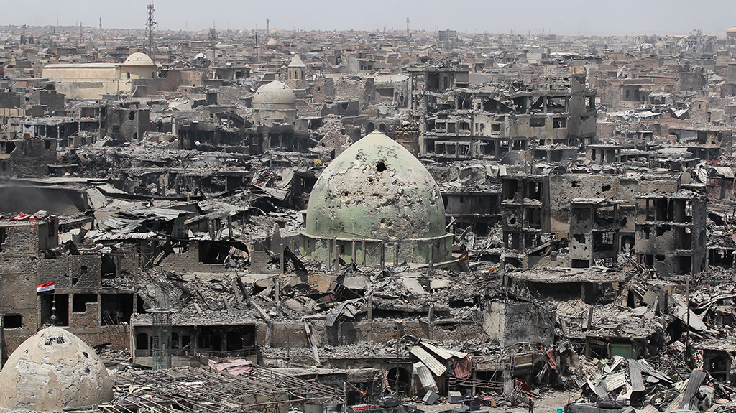
- The call of the Lord

- Story
Again the LORD addressed Jonah: "Get ready and go to Nineveh, the big city, to complain to her with the words I tell you. Jonah 3.1-2

Following on this workshop is a visit to a German and a British cemetery in Flanders Fields in remembrance of 100 years history since the First World War.
We will walk from one cemetery to the other in silence. During the walk we will connect our own bibliodrama experience from the past 2 days with the memorial walk. The theme of the conference “Pieces of peace” enclose the political and social issues of Europe nowadays as well as the story of Jonah who was called to go to Nineveh (Mosul).
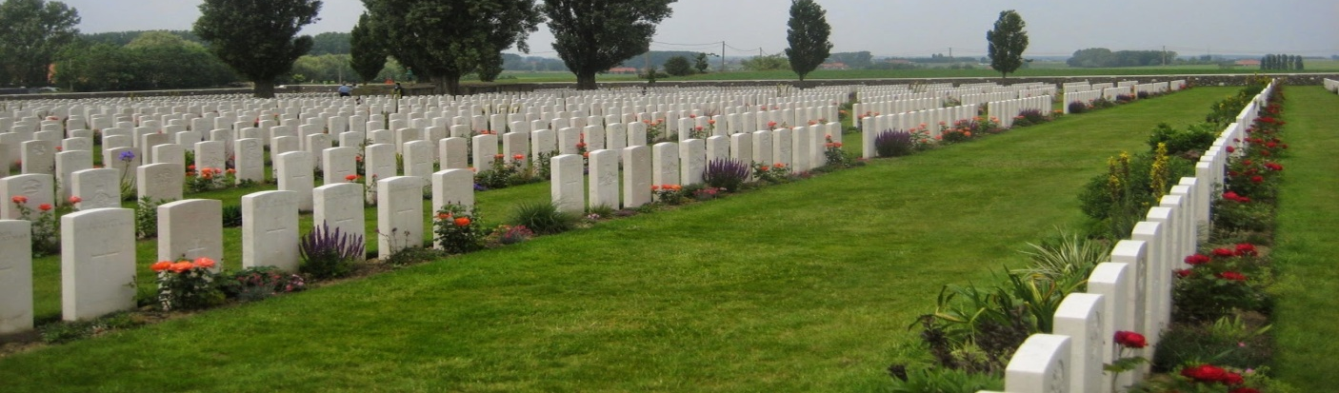

- Play in two parts
Half of the participants play Jonah, the other half plays the role of God. In part 2 there is a change of roles.
The players stand in a half (or whole) circle on Jonah in the inner circle, God behind.
Those who play Jonah live like Jonah thrown on the beach and bodily / mentally experience their situation that moment. The players in the role of God do the same. In turn, one Jonafigure speaks of (situation, experience ...), on which the “God-player” rephrases in his/her own way the Bible quotation: "Get ready and go to Nineveh, the big city, to charge it with the words I say to you." Jonah gives his own answer.

Jonah begins to explain his own experience or makes a statement from his experience: sitting, lying, standing on the land, in the sight of God.
The other participant who plays the role of God may sound the Bible words from Jonah 3.1-2, from literally to fully adapted to what Jonah has said, expressed, expressed or what lives within him/her ...
Then there can be a response from Jonah: an answer to the situation or to God's speech

If everyone has gone through this scene, it will be unrolled and roles will be changed.

Exchange
Possible exchange in two groups of the experience of being Jonah / God
In order to encounter our own personal development towards the story of Jonah related to our own lives.

- Moment of suitcases
What do you want to remember? In which creative way could you ‘present’ these memories and thoughts? Use pencil, objects, colours … to express your thoughts and feelings.
Which thoughts do you take with you while walking in Flanders Fields? The bus takes us to an unknown place, filled with memories, hope and despair. What does this mean to you?
While expressing our thoughts and feelings on paper, two songs are played: “Where have all the flowers gone” and “Sag mir wo die Blumen sind”.

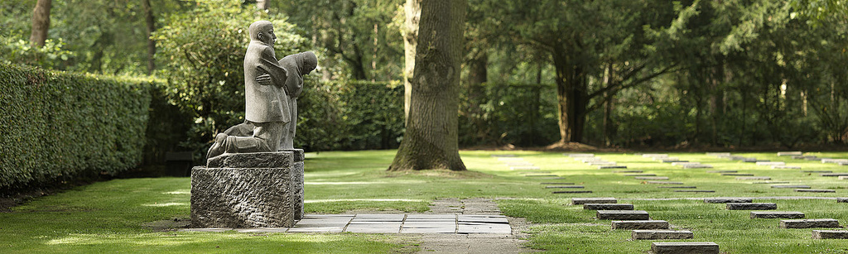

- The Dance – not to be worked out (just a small possibility)
The dance wants to be a ritual expression of learning to deal with vulnerability. As human beings, we are limited in possibilities, we carry our problems with us. If our masks of being tough and strong are put away, we notice how fragile we are. Thrown on the land we experience ourselves (like Jonah) again as we are truly in the face of the world and of a calling God.

The dance shows in gestures the doubt, the fear, the flight response for this call in the daily course of the life in which we, even though moving forward, we yet too often want to return. The dance contains the invitation to show our vulnerable inside. But in the dance we are not alone with our vulnerability. We recognize our vulnerability in others and vice versa. With and in our vulnerability we try to grow and continue in life. Shoulder to shoulder. Step by step. In the dance, we cherish this vulnerability and show it to our outside world, even more share it with the outside world. Thus we are invited to search for a stronger connection with the group and to deepen this step by step. Connected with each other, being aware of our vulnerability, is essential to faith.

Steps of the dance

The dancers stand in a circle face to face and hand in hand.
The dance begins with the right foot and extends in the right direction, counter clockwise. The dance starts with eight steps forward. Then four back and forth four forward.
Then the dancers turn in the face and the body and put four small steps towards the center of the circle towards each other while keeping the arms at shoulder height. The center symbolizes the holy, the good, the call of the divine ...
Stepping to the center the dancers gently shake their hands stretched out. They symbolically show their existence and vulnerability to each other.
After the four passes forward (the dancers are close together, shoulder to shoulder), they put two passes sideways to the right: i.e. to the right side, left there and left to the right to the left. In our vulnerability, we are trying to get ahead. Step by step, shoulder to shoulder, we know that we support others as well are supported by others.
Then they cross their arms and hands for the chest and step back four steps. We cherish this new experience and return to our own life situation. We are invited to show this new experience to the world.
In the dance, this goes as follows: In four steps, we turn left in an arch to return to the starting point. You walk a little round outside the starting point of the dance circle. Meanwhile, we extend our arms and hands to the outside world. We express our willingness to share our experiences.
Then the dancers quickly search each other's hands and then the dance starts again with the eight steps forward ...

