Aarons Blessing

Y’va-re-che-cha Adonai v’yish-mire-cha
Ya-er Adonai panav elei-cha vihu-necha
Yi-say Adonai panav elei-cha
V’ya-sem l’cha shalom (2x)

The Lord bless you and keep you
May the Lord shine His Face upon you ( 2x)
And be gracious unto you
May the Lord look upon you
And give you peace (2x)
A Hebraic interpretation of the Aaronic Blessing
With the Hebraic understanding of each of these Hebrew words, we can better understand the true meaning of the Aaronic blessing as it was understood by the Ancient Hebrews.
YHWH will kneel before you presenting gifts and will guard you with a hedge of protection.
YHWH will illuminate the wholeness of his being toward you bringing order and he will give you comfort and sustenance.
YHWH will lift up his wholeness of being and look upon you and he will set in place all you need to be whole and complete.

Lo Yissa Goy

t.: Jes. 2,4 Micha 4,3
m.: Asjkenazich

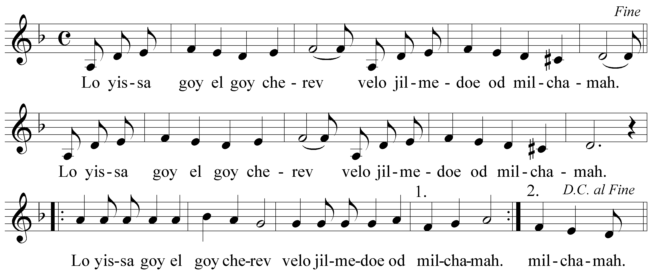

Geen volk heft het zwaard meer tegen een ander
en oorlog leren ze niet meer.

John Lennon - Imagine

Imagine there's no heaven
It's easy if you try
No hell below us
Above us only sky
Imagine all the people
Living for today...
Imagine there's no countries
It isn't hard to do
Nothing to kill or die for
No religion too
Imagine all the people
Living live in peace...
You may say I'm a dreamer
But I'm not the only one
I hope someday you'll join us
And the world will be as one
Imagine no possessions
I wonder if you can
No need for greed or hunger
A brotherhood of man
Imagine all the people
Sharing all the world...
You may say I'm a dreamer
But I'm not the only one
I hope someday you'll join us
And the world will live as one

Where have all the flowers gone?
Long time passing.
Where have all the flowers gone?
Long time ago.
Where have all the flowers gone?
Young girls picked them every one.
When will they ever learn?
When will they ever learn?
Where have all the young girls gone?
Long time passing.
Where have all the young girls gone?
Long time ago.Where have all the young girls gone?
Gone to young men every one.
When will they ever learn?
When will they ever learn?
Where have all the young men gone?
Long time passing.
Where have all the young men gone?
Long time ago.
Where have all the young men gone?
They are all in uniform.
When will they ever learn?
When will they ever learn?
Where have all the soldiers gone?
Long time passing.
Where have all the soldiers gone?
Long time ago.
Where have all the soldiers gone?
Gone to graveyards every one.
When will they ever learn?
When will they ever learn?
Where have all the graveyards gone?
Long time passing.
Where have all the graveyards gone?
Long time ago.
Where have all the graveyards gone?
Covered with flowers every one.When will they ever learn?
When will they ever learn?

"Where Have All the Flowers Gone?"
is a modern folk-style song.
The melody and the first three verses
were written by Pete Seeger in 1955.
Additional verses were added
in May 1960 by Joe Hickerson,
who turned it into a circular song.
Its rhetorical "where?"
and meditation on death
place the song in the ubi sunt tradition.
The song was sung
at the funeral of Harry Patch,
the last British soldier of the First World War,
in Wells Cathedral on August 9, 2009.
In 2010, the New Statesman listed it
as one of the "Top 20 Political Songs".

Sag mir wo die Blumen sind,
wo sind sie geblieben
Sag mir wo die Blumen sind,
was ist geschehen?
Sag mir wo die Blumen sind,
Mädchen pflückten sie geschwind
Wann wird man je verstehen,
wann wird man je verstehen?
Que sont devenues les fleurs
du temps qui passe
Que sont devenues les fleurs
du temps passé
Les filles les ont coupé
elles en ont fait des bouquets
Apprendrons-nous un jour
apprendrons-nous jamais ?
Waar zijn al de bloemen toch
Waar zijn al de bloemen toch,
van lang geleden
Waar zijn al de bloemen toch,
waar zijn ze nu
Waar zijn al de bloemen toch,
meisjes plukten ze en of
Wie van ons weet dat nog,
wie van ons weet dat nog?
Inga blommor finns det mer.
Det är sommar.
Ingen sommaräng vi ser.
Säj vad har hänt?
Inga blommor finns det mer.
Flickor plocka blommorna.
Lär dom sej aldrig nåt?
Lär dom sej aldrig nåt?
Gdzie są kwiaty z tamtych lat?
Jasne kwiaty...
Gdzie są kwiaty z tamtych lat? -
Czas zatarł ślad...
Gdzie są kwiaty z tamtych lat?
Każda z dziewcząt wzięła kwiat...
Kto wie czy było tak...
Kto wie czy było tak...

Missä, missä kukat on,
tullut kesä on,
kukkaset on kadonneet,
tiedätkö syyn?
Kukkaset on kadonneet,
tyttösen ne poimineet.
Voi milloin muistat sen,
voi milloin muistat sen!
Hova tűnt a sok virág,
mely ott nyílt a réten
Hova tűnt a sok virág,
velük mi lett?
Hova tűnt a sok virág,
lányok tépnek bokrétát
Óh mondd ki érti ezt,
oh mondd ki érti ezt?
Kuhu küll kõik lilled jäid,
mis on neist nüüd saanud?
Kuhu küll kõik lilled jäid?
kaob kiirelt aeg …
Kuhu küll kõik lilled jäid?
Neiud tuppa õied tõid.
Mil ükskord mõistad sa,
mil ükskord mõistad sa.
Kur ir ziedi, dod man atbildi,
kur viņi bija?
Kur ir ziedi, dod man atbildi,
kur tie aug?
Kur ir ziedi, dod man atbildi -
meitene neapmierinātas, un ka tie nav.
Kad visi saprotam?
Kad visi sapratīs?
Dove son finiti i fiori,
se passato il tempo è già?
Dove son finiti i fiori
di tanto tempo fa?
Dove son finiti i fiori? ...
Li hanno colti le ragazze ora.
E non han capito ancora?
Non impareranno mai allora.

Fading away like the stars in the morning
Losing their light in the glorious sun
Thus would we pass from this earth and its toiling
Only remembered for what we have done
Only remembered, only remembered
Only remembered for what we have done
Thus would we pass from this earth and its toiling
Only remembered for what we have done
Only the truth that in life we have spoken
Only the seed that in life we have sown
These shall pass onwards when we are forgotten
Only remembered for what we have done
Only remembered, only remembered
Only remembered for what we have done
These shall pass onwards when we are forgotten
Only remembered for what we have done
Who'll sing the anthem and who'll tell the story
Will the line hold, will it scatter and run
Shall we at last be united in glory
Only remembered for we hat have done
Only remembered, only remembered
Only remembered for what we have done
Shall we at last be united in glory
Only remembered for what we have done
Only remembered

Old-English hymn performed by the British a-capella-trio Coope, Boyes en Simpson
at the peace concert in Passendale "We 're here because we 're here" in 1994.
The first verses are traditional:
Dr. H. Bonar of Edinburgh wrote the words of this hymn which Sankey set to music in 1891.
He sang it as a solo in The Tabernacle in London at the funeral of his friend, C.H. Spurgeon,
a great London preacher. John Tams, English poet and playwriter, added another verse.
Hymns were often sung in times of war.
They were expressions of solidarity and togetherness
that went beyond rank and condition,
beyond life and death.

Zal er ooit een dag van vrede
zal er ooit bevrijding zijn
voor wie worden doodgezwegen
levenslang gebroken zijn?
Zal er ooit een blijvend heden
vol van goede vrede zijn
waar geen pijn meer wordt geleden,
en het leven nieuw zal zijn?
Zie de takken aan de bomen
waar het jonge groen ontluikt
tot een stralend nieuwe zomer
waar de vredesbloesem ruikt.

Zoals bomen mensen tonen
dat er kracht tot groeien is,
zal de zoon der mensen komen
die de boom des levens is.

Will there ever be a day of peace
will there ever be release
for those who are ignored
and broken for a lifetime?

Will there ever be a lasting present
full of good peace
where no more pain is suffered,
and life will be forever new?
See the branches on the trees
where the young greenery is opening
to a brilliant new summer
where the peace blossom smells.

As trees prove to people
that there is strength to grow,
the son of men will come
he who is called the tree of life.

‘Will there ever be a day of peace’,
a song by Henk Jongerius,
born on December 7, 1941 in Utrecht,
became a priest on July 11, 1966 in Nijmegen,
lives in the Dominican Monastery in Huissen since 1967,
cantor, publicist and liturgist.
The melody, called ‘Goldschmidt ‘,
comes from the Chorals Book for England,
1863.

SONGS

Pieces of PEACE

