European Basic Training for Bibliodrama

The European Bibliodrama network (ebn) is organizing trainings at different levels for participants from different countries.

BASIC COURSE
for leading Bibliodrama, in multicultural and multilingual contexts in accordance with the ebn-Charter:

o 120 lessons of 45 minutes.
o Directors: Lotta Geisler and Lars-Gunnar Skogar, schwedische Bibliodrama-Gesellschaft, Stockholm, Sweden; www.bibliodrama.se, and Bibliodramainstitutet, www.bibliodramainstitutet.se
Andrea Brandhorst and Wolfgang Wesenberg, Gesellschaft für Bibliodrama – Hannover, Germany
o Where: Bromma folkhögskola, Stockholm
o When: 2022, June 27th to July 9th
o Competence gained: working with elements of Bibliodrama in your own practice
o Requirements: theological or religious education and experiences as a leader of adult groups
o Participants: max. 15
o All courses will be in broken bad basic 😉 - English.
o We hope there will be at least two participants from each country.
o Each participant will receive a special certificate from the Adult Education Center in Bromma, as well as from the European Bibliodrama Network at the end of the course.
o After the Basic course the participants must plan, lead and document a Bibliodrama. After that the participants can attend the advanced course for leading Bibliodrama beginning 2023.
o Costs around: 1500 € Course fee; 450 € meals; 230 € lodging at school; 1000 € lodging at hotel. Financial support is possible.
o For costs and further information ask:
Wolfgang.Wesenberg@Bibliodrama-Gesellschaft.de or andrea.brandhorst@web.de

Concerning Covid-19: we expect that the training will take place. If you have to cancel because of Covid-19 it is cost-free.
To apply for the training is possible from now, please contact W. Wesenberg or A. Brandhorst. The number of participants is limited. The order of registration will be taken into account.

Mentoring Team of the Bibliodrama Facilitator Training
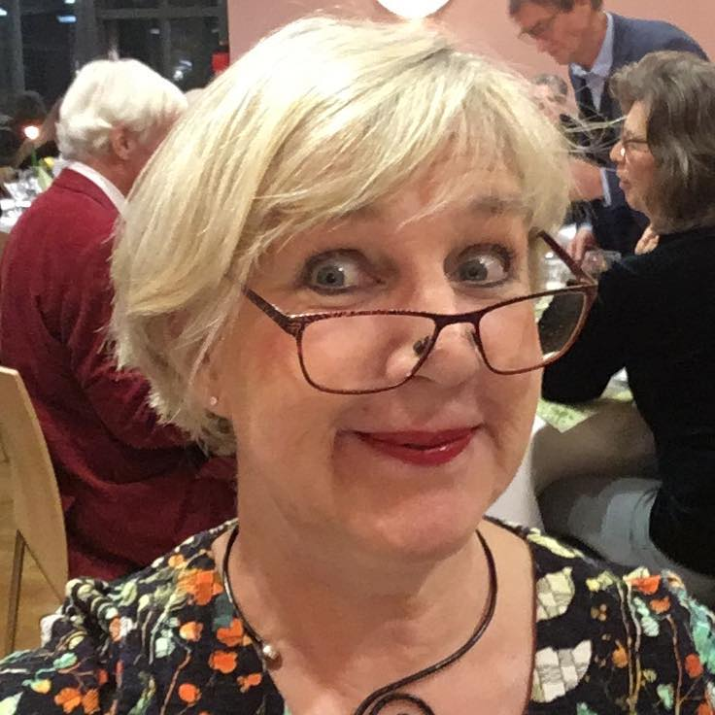 | Lotta Geisler,  Jakobsberg / Stockholm, Social pedagog, deacon and diploma 'expressivearts therapist'. Bibliodrama trainer in Sweden. | 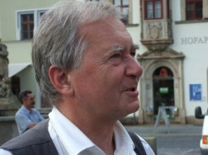 | Dr. Wolfgang Wesenberg,  Berlin,  prot. Minister, adult education,  Lehrbibliodramaleiter (GfB),  editorship TEXT RAUM – Bibliodrama-Informationen,  training courses for Bibliodrama
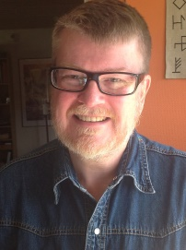 | Lars-Gunnar Skogar,  Grycksbo / Falun, Minister, hospital chaplain, spiritual guide. Bibliodramatrainer in Sweden. | 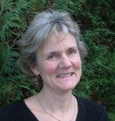 | Andrea Brandhorst,  Bielefeld,  Dipl.Päd, teacher Lehrbibliodramaleiterin (GfB), Yogateacher (BDY/EYU),  training courses for Bibliodrama, bodyawareness and meditation.
Information and enrolment |  | Andrea.Brandhorst@web.de  Wolfgang.Wesenberg@Bibliodrama-Gesellschaft.de  0049 171 186 02 07  www.bibliodrama-gesellschaft.de

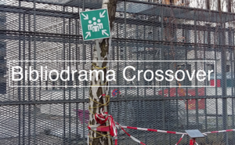

European advanced training for Bibliodrama starting in May 2023 until May 2025.

